IFT 166 Introduction to Internet Networking

Lab 6
Collision & Broadcast Domains

OBJECTIVES: To understand collision and broadcast domains

Collision & Broadcast Domains
www.youtube.com/watch?v=_c1gqcr6Lcs
www.youtube.com/watch?v=s3pq0bdZMz8

Hub
- 1 collision domain (no matter how many ports)
- If a hub is connected to another hub then still only 1 collision domain as the connected hub will also receive the message and send it to all connected ports

Switch
- Each port is 1 collision domain
- Link between two switches - 1 CD
- Link between a switch and a router - 1 CD

Router
- Each active port is 1 collision domain
- Each active port is in its own broadcast domain
- Broadcast domains are usually separated by a router since a router does not propagate/forward broadcasts
- Link between two routers - 1 CD
- Link between a router and an end device - 1 CD

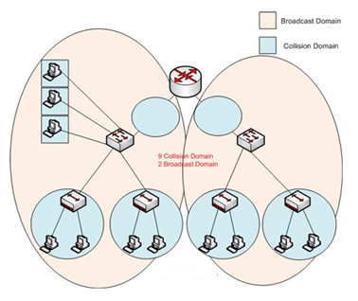

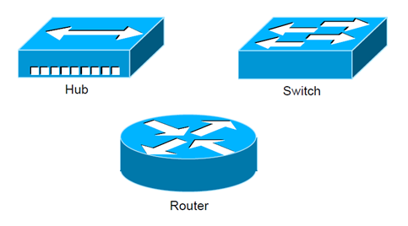

Now you try these……………………..
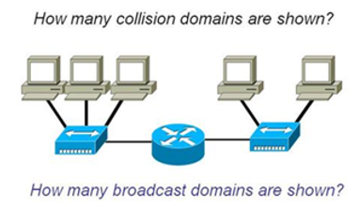
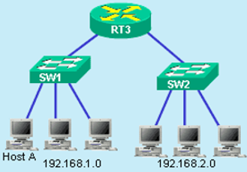

CDs: 4 BDs: 2 CDs: 8 BDs: 2

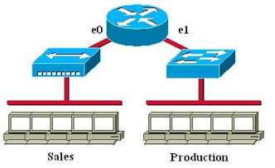
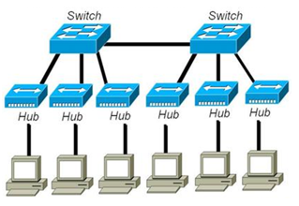

CDs: 13 BDs: 0 CDs: 8 BDs: 2

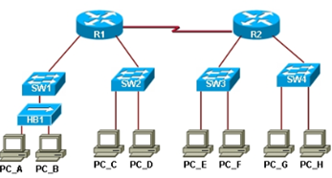
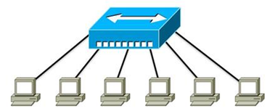

CDs: 1 BDs: 0 CDs: 12 BDs: 4

